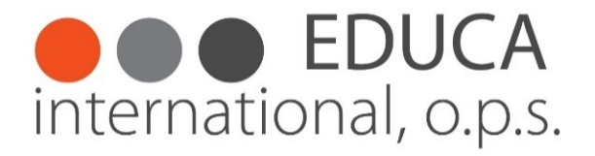

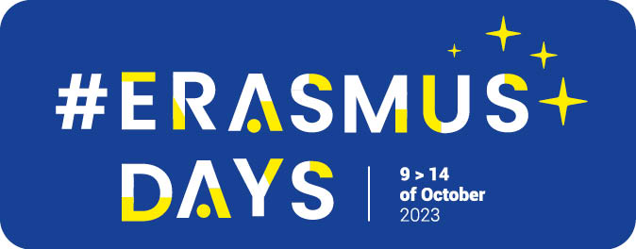

Erasmus Days

Photocompetition 2023 - conditions

Organiser
The organiser of the photocompetition is EDUCA International, o.p.s., IČ: 28187172
Company head office: EDUCA International, o.p.s. Na Moklině 289/16 163 00 Praha 6
Workplace: EDUCA International, o.p.s. Strojírenská 260/14, 155 21 Praha – Zličín

Theme
„Education for all“

Date
The photo competition will take place from 01.07.2023 do 08.10.2023.
During this period, you have the oportunity to continuously send photos with a short description.
PHOTOCOMPETITION WILL TAKE PLACE ON THE INSTAGRAM ACCOUNT AND VIA E-MAIL
The announcement will take place during November 2023.

Participants of the photocompetition
Participation in the competition is without restrictions of age, gender, freedom of religion or nationality.

Number of pictures
Each participant can enter the competition for min. 1 and max. 3 photos.

Technical specification of competition photos

- file format: JPG
- format / aspect ratio of the photo: any (portrait, landscape, square, panorama)
- minimum size / resolution: ~ 6 Mpix (longer side of photo at least 2560 pixels)
- maximum file size: 20 MB
- photos from mobile phones / tablets / cameras: yes, unlimited
- a title (max. 30 characters) and a story (max. 500 characters) can be attached to the photo

Photos that do not meet the above requirements will not be accepted into the competition.

Signing up for the photo contest
It is possible to apply for the photo contest by sending an email with a short description of the photo/photos and uploading them to the email educa.fotosoutez@seznam.cz

and/or via Instagramu account of Educa International https://www.instagram.com/educacz/
INSTAGRAM COMPETITION TERMS:
- Choose 1 to 3 photos from your Erasmus+ mobility that are your "BEST"
- Tag our profile @educacz in the post
- Follow our profile @educacz

The photos accepted into the competition will be continuously presented on social networks, especially FCB and Educa International's Instagram account.

Evaluation of photos / jury
Photos will be evaluated / scored by an expert jury composed of:

- JUDr. Josef Vochozka
- Mgr. Monika Kašová Fatková
- Bc. Kateryna Marodi
- Mansi Mishra
- Goknur Taniyan
- Petra Klačková
For each competition photo, the jury will make an anonymous point evaluation, and then 3 participants will be announced in each category, whose photo received the highest number of points. In the event that several photos receive the same number of points, the ranking will be decided by the sum of the points of all the participant's competition photos. In case of equality of points between several participants, e.g. two first / second / third places can be announced.

Point evaluation
Topic: 0 – 50 points (interest / originality of the topic / compliance with the topic is evaluated)
Overall impression: 0 – 50 points (the overall impression of the photo, composition, color and technical quality are evaluated)

Prices
Promotional materials of the Czech National Agency for International Education and Research, promotional materials of Educa International o.p.s., interesting books and other non-material prizes.

Objections, complaints

The organizer makes the final decision on complaints, objections or ambiguities, at the same time reserving the right to change the conditions of the competition or to cancel the competition without giving a reason. In such a case, the organizer is not obliged to evaluate the competition or award prizes.

Elimination from the competition
The organizer reserves the right to exclude from the competition photos / participants who do not meet the specified conditions.

Participant consent
By submitting the application, the participant agrees that the submitted images will be used by the organizer to promote foreign mobilities within the Erasmus+ program by publishing in the press or other media, on advertising surfaces or in electronic form, on social networks, on promotional materials and objects of Educa International, o.p.s. etc. without entitlement to a fee.

By sending a photo to the competition, the participant confirms that he is the author of the photo and that he is authorized to use the photo. Should such entrant's claim prove false, such photo may be disqualified from the contest, deleted, and the entrant may be disqualified from the contest without compensation. Therefore, the participant acknowledges that he assumes responsibility for damage that may occur to the organizer or third parties as a result of a violation of this condition.

The organizer does not assume any responsibility for the content of the photos, for the violation of the rights of third parties by their display in the photo or the use of the photo by the organizer in good faith in accordance with these conditions.

When taking photos, each participant is obliged to proceed in accordance with legal regulations, to take into account the legitimate interests and rights of third parties, especially the people in the photo and their privacy and rights to the protection of personality.

By submitting a photo to the competition, the participant clearly indicates to the organizer that he has fulfilled the conditions of this paragraph and that he agrees to be fully responsible for the violation of these rights.

GDPR for competition participants
If there is an identifiable likeness of people in the photographs, then the author of the competition photograph will secure their consent to the publication of their likeness.
Educa International o.p.s. ensures the processing of contestants' personal data in accordance with the applicable legislation, namely, registration no. 110/2019 Coll., on the processing of personal data as amended.

