Assessment of Quality of Erasmus Traineeship - AQET
Project n. 2019-1-CZ01-KA203-061393

(Final Report)

Part 1

- Introduction of the AQET project
The AQET project (Assessment of Quality of Erasmus Traineeship) aims to evaluate the activities of trainees by institutions/companies/firms involved in the Erasmus programme, so that these evaluations are useful for the sending institutions and especially for the trainees themselves. The project was implemented as a three-year Erasmus+ project (activity KA2). The main output is the design of a form for the evaluation of trainees by institutions, which would allow evaluation not only from the professional, but also from the social side of the trainee and would also be usable for their professional portfolio as well.
The Erasmus traineeships started in 2007. From a slightly hesitant start in 2007, interest in traineeships gradually increased, mainly due to growing support from universities and the promotion of the programme in institutions and companies. The traineeship program has been updated in various ways, and currently the opportunity to participate in internships is open to all students of universities involved in the Erasmus program, regardless of their citizenship, as well as to university graduates within 12 months of completing their studies. The traineeship spent abroad helps students better cope with the demands of the labour market and gain new knowledge and experience. This form of cooperation also increases the possibilities of cooperation between educational institutions and companies.
The increasing importance of Erasmus traineeships stresses the need for quality and relevance for the assessment. While for the Erasmus mobility study programme the European Credit Transfer System (ECTS) is settled, there is a lack of guidelines and precise rules for the assessment of traineeships.
The evaluation forms used in the Erasmus program are very general for traineeships and give the opportunity to evaluate the activity of trainees in a very general way. Such evaluations do meets the criteria of the Erasmus programme, but they are of little or less importance, since the participants of the internships cannot use them sufficiently, for example, when submitting job applications and documenting previous experiences.
This project follows on from the previous ATEST project, which was focused on the issue of recognizing traineeships as part of studies and assigning credits (ECTS) for participation in an internship. As part of the research carried out by the ATEST project, companies pointed out that there are no precise rules for the involvement of trainees in the company's activities and, above all, there are no precise rules for evaluation. In addition, in 2014, the Erasmus program was extended to include university graduates, and the evaluations are not of sufficient quality to be used, they are used to document experience when applying for a job.

- Project Partners
The comprehensive project consortium consisted of partners active in Erasmus traineeships. The partnership for the project cooperation was established to represent different regions with participation of universities geographically covering the whole Europe - from West to East and from North to South. There were 6 participants involved from 5 EU countries, of which five of them were universities:
- Educa International, o.p.s. (coordinator)

- Edinburgh University, Great Britain
- University of the Basque Country, Spain
- Deggendorf Institute of Technology, Germany
- Pavol Jozef Šafárik University in Košice, Slovakia
- Metropolitan University Prague, Czech Republic

Project partners were invited to the project based on previous cooperation and good experiences in the Erasmus mobility programme and all of them were actively involved in the project work and contributed with their expertise to tackle the project task. There was no project partner without previous mobility project experience. Four project partners were participating on previous project ATEST and 2 partners were new ones (Metropolitan University Prague (CZ) and Edinburgh University (UK).

Educa International, o.p.s. is a private NGO located in Prague (CZ) oriented to Erasmus mobility activities of the Czech universities. It´s an Erasmus consortium representing 19 Czech universities in Erasmus+ traineeship activities. The main activity within the consortium is traineeship mobilities for graduates.
The Erasmus traineeship activities are developed in close cooperation with universities. Each university is responsible for selection of own students nominated for traineeship and confirmation of each individual application and Learning Agreement for Traineeship (LA). Educa provides all other administrative steps – confirmation of LA and signing agreements, payment of grants, administrative evidence of contracts and responsibility for final reports distribution of Certificates to participating students or graduates.
Each planned internship at a foreign institution must be documented by the applicant and must be confirmed by the sending university and the receiving foreign institution. Despite these confirmations, Educa checks the eligibility of participation in the traineeship (allowed duration of the internship, suitable institution, etc.). Subsequently, after the start of the traineeship, Educa is in contact with trainees and with institutions. If the situation requires, we solve any problems. After the end of the traineeship, we evaluate the final document and reporting participation in the traineeship.
The budgets for traineeships in the years 2018-2020 were as follows:
 | Budget allocation | Budget used | Total Trainees | Students | Graduates
2018 | 348 583,00 € | 348 583,00 € | 158 | 81 | 77
2019 | 308 430,00 € | 308 430,00 € | 148 | 39 | 109
2020 | 277 959,00 € | 277 959,00 € | 134 | 24 | 110

Some bigger Czech universities are not supporting mobility for graduates and pass them to Educa and the number of participating graduates is growing every year

University of the Basque Country, Spain
The University of the Basque Country offers both Erasmus traineeships programmes, for students and graduates. Because of this difference between students and graduates, the university created two separate Erasmus traineeship programmes called: Ikaslepraktikak for
students and EPEZ – Erasmus internships for graduates, each of them with different procedures and deadlines.
Ikaslepraktikak - there is a double assessment model: one academic done by the tutor, and the final evaluation report made by the trainer of the company or organisation. The recognition of the favourably assessed internship periods corresponds to the Internship Programme Manager of the centre in which the student is enrolled, and is based on the final internship report drawn up by the student, and the final evaluation report drawn up by the trainee of the collaborating entity.
EPEZ Programme - in the EPEZ programme, the certificate issued by the company includes not only the formal details of duration, host institution and name of the placement, but also the work programme carried out with the list of tasks performed, a schedule by blocks of weeks, and finally, the competences acquired during the placement.
In the last years, the most popular destination countries for Erasmus internship students have been Italy, Portugal and Germany, but there is also a growing interest in countries of central Europe like Austria and Poland.

Edinburgh University, United Kingdom
The internship programmes contribute to improving the professional prospects of its graduates through the development of skills that will enable them to successfully face the labour market. These programmes also serve to raise awareness of the importance of international mobility in order to create generations that are free and respectful of other cultures and societies. However, in the case of the accreditation of the traineeship for graduates, a more detailed certificate than the one commonly used by companies can be particularly useful for recent graduates who are facing the internship period, not so much as a complementary training to their studies, but more focused on defining their career path. Although this certificate has no legal validity, can have a high individual value, leading to increased levels of self-confidence.

Pavol Jozef Šafárik University in Košice, Slovakia
The Pavol Jozef Šafárik University in Košice, Slovakia, recognises international traineeships either as substitutes for a traineeship in a curriculum or as an activity outside of the curriculum. The traineeships are available for the students of the university as well as for its recent graduates. The majority of the Erasmus+ traineeships are facultative, but it has to be confirmed by the faculty/institute/department Erasmus coordinator if the traineeship is a useful supplement to the studies. Mobility is considered as successfully finished, only if the student achieves the results that are in accordance with his/her Learning Agreement for Traineeships. The student&#39;s obligation is not only to stay abroad for the period of his/her mobility, which is specified in his/her Grant Agreement but also to fulfil the goals that were set in the approved Learning Agreement for Traineeships. In case the student fails to fulfil the goals that were set in the approved Learning Agreement for Traineeships, the university may ask the student for a full or partial refund of the financial support awarded.

Deggendorf Institute of Technology, Germany
Students can apply for the scholarship once they have an traineeship offer and a contract with a company or institution abroad. The application procedure is done with Mobility Online. Mandatory traineeships embedded in the curriculum are given preferential treatment, students with voluntary traineeships can apply as well, and few to no graduate traineeships.
Evaluation of the traineeship – students have to submit the ´After the Mobility´ - form signed and stamped by the traineeship company, complete the EU survey and submit a written report (3-5 pages, in the future this will be recorded digitally and provided to interested students in a database). Companies can issue traineeship certificates or provide a reference, depending on what they agreed with the students.

Metropolitan University Prague, o.p.s.
Metropolitan University Prague(MUP) has been involved with Erasmus traineeship mobility since 2008, and students take only optional traineeships. Upon beginning participation in Erasmus internship activities the participants receive 5 ECTS if they fulfilled the conditions of traineeship - duration at least two months and declaration of an assessment made by foreign institution. Any such traineeship must be confirmed by the head of the faculty and subsequently is entered into the SIS (Student Information System). Based on the experience of the first years of participation in the Erasmus traineeship programme, the system for the recognition of traineeships has been enhanced and currently students participate in traineeships, which are done on a voluntary basis, but students can enrol their traineeship as an elective course, and thus a traineeship becomes part of the curriculum. Students gain 5 ECTS for traineeship and it becomes part of the curriculum and the credits are counted in the overall summary of ECTS per a semester or an academic year (30 or 60 ECTS). 5 ECTS corresponds to ratings for compulsory optional subjects for MUP students.
The evaluation criteria to be taken into account by the Selection Committee is as follows:
a) Accredited language level of the host country and/or level of English: C2 certificate of the Common European Framework of Reference for Languages, or equivalent qualifications: up to 60%.
b) Specific merits (personal interview and CV evaluation) related to the current EPEZ project: 30%.
c) Average mark of the academic transcript: 10% (in the case of master&#39;s degrees, the mark of the degree that gives access to the same will be considered).
Application prerequisites:
The traineeships to be carried out by the students must be directly related to the studies in which they are enrolled. The students might be asked by the host organisation to accredit sufficient knowledge of the working language in which the internship will be carried out. The level of language is evaluated usually by the host organisation not by the MUP.
In addition to the general requirements of the Erasmus Programme, before the start of the mobility, students must be enrolled at the MUP in studies leading to the award of an Official Degree, from Bachelor&#39;s Degree to Doctorate inclusive. In the case of graduated students, the applicant has to submit the application before the final state examination. The date of the final state examination is considered and the first day of the 12 months period during which the graduated student may pursue the traineeship.
As stated in the Erasmus Programme Guide students can pursue the traineeship already in the first year of their Bachelor studies. The internal rule of MUP requires students to conclude the first semester of studies at MUP before leaving for a traineeship. If the student is enrolled on a degree programme which is accredited as a professional programme that requires a compulsory traineeship as part of the curricula the traineeship pursued under the Erasmus+ can be considered as fulfilling of this compulsory component.
The Most popular destinations:
In the last years the most popular destination countries for Erasmus internship students have been Italy, Spain and Germany, but the is also a growing interest in countries of Scandinavia like Finland and Sweden.
Evaluation of the traineeship
The evaluation of each traineeship depends on whether it relates to a student or graduated one. In case of a student, the evaluation and recognition is in first stage made by the International Office by revision of the documents submitted after the traineeship as well as simple interview with students on strengths and weaknesses of the traineeship as well as some recommendations and insight of the trainee. In case they are not trainees that would perform the traineeship in order to complete the compulsory curricula component the traineeship is recognized as a free choice course and language. In case the trainee is studying a professional degree-oriented programme hence having the traineeship as a compulsory component the second stage of evaluation is needed. This second stage is done by the responsible person for the particular department. The evaluation includes face-to-face interview, writing of a report and submission of the evaluation in written form. Recognition of the traineeship is done by the department itself.

The importance of internships for future career
Metropolitan University Prague value the Erasmus+ programme and consider it a vital part of the student future career as well as professional and personal development. The traineeships programme at our university aims to promote the employability of MUP students and graduates and to facilitate their incorporation into the labour market. The traineeship programmes contribute to improving the professional prospects of its graduates through the development of skills that will enable them to successfully face the labour market. These programmes also serve to raise awareness of the importance of international mobility in order to create generations that are free and respectful of other cultures and societies.
However, MUP runs only two professional orientation programmes, the Tourism and the Financial Management Erasmus+ is considered and promoted as a programme that enables students to get experience from the multicultural environment of companies and organizations that leads the student to understand the environment and culture of a working place as well as help the student to look after opportunities with self-confidence and language proficiency.

3. Methods of Work
Objectives
The aim of the project is to design and create a document for higher quality evaluation of traineeships in the Erasmus+ program and thus improve the quality of documents issued to traineeship participants after their completion, which will have an impact on the administrative process of evaluation and recognition of student traineeships.
For university graduates who complete an internship after graduation, the evaluation of their traineeship is very important for the job search, and only a high-quality evaluation will be respected by future employers.
The European Commission emphasized that "a specific traineeship that is not part of the student's study plan is recognized by the sending institution at least by indicating the traineeship period in the Diploma Supplement, or in the case of graduate internships, by providing an traineeship certificate". However, there are no universally accepted rules for evaluating traineeships, respectively trainees based on a quality questionnaire. This is the reason why some European universities require special evaluations from companies and also from the students themselves, as the documents required by the EU Commission do not have sufficient explanatory value.
General Objectives
• implementation of the recommendations contained in the "European Quality Charter for Mobility" in the field of higher education;
• support at European level the creation of mechanisms to support the exchange of best practices and the involvement of the main criteria that define the quality of traineeships, as set out in the European Quality Charter for Traineeships.

Specific Objectives
• propose a set of recommendations to contribute to the quality of mobility assessment procedures and to improve the recognition of internships within the curriculum and qualifications of students and especially graduates;
• enable a better common understanding of the specific aspects of Erasmus internships

Working Methods
In order to achieve the goals of the project, Educa International, o.p.s. as coordinator and partner universities considered it necessary to use work methods combining work meetings of all members of the project team and individual work.
The kick-of and project meetings proved to be an effective means of facilitating smooth communication between partners, however, with the onset of the covid-19 pandemic, communication became very complicated and assigned tasks were postponed until a suitable time for direct communication. In September 2020, a meeting of 4 project partners was held in Deggendorf (other two partners from SK and UK participated online). The subsequent impossibility of traveling finally led the work online and several online working meetings were held and only in the final phase of the project 2 meetings took place (Košice, Slovakia and Bilbao, Spain). However, not all partners were represented here either.
An associated partner was included to the project (ACCESS EU!) - the institution located in Brussels with many excellent experiences in cooperation with universities and trainees. The Covid-19 did not allow us to visit the institution and finally after covid pandemia the institution closed the office and coordinator asked all partners to recommend any other institution with a good traineeship experiences. Finally there was only one recommended institution in Prague (Czech Centre) with many offices located in EU countries. The meeting was realised during the last project month (August 2022) and again not all partners could participated – only Educa, Metropolitan University Prague and Pavel Josef Šafárik University in Košice participated. It was a two-day training with information on the form of cooperation with universities, the selection of trainees, the work of tutors and trainers with them and final evaluation system.
As part of the first project meeting, a work plan was drawn up and a project steering committee was established from all partner institutions, the aim of which is to ensure efficiency, decisiveness, flexibility and quality of work throughout the duration of the project. The first period of the project was focused on independent work in each partner country. As the project coordinator, Educa collaborated with members of the consortium as well as with other European universities and especially with companies and institutions to obtain data for the analysis of existing models for evaluating the results of traineeships in greater detail.
The aim of this project was not to perform an exhaustive analysis of traineeship evaluations by companies involved in the Erasmus+ program. A study of that magnitude would be incomprehensible for partners and exceed the project’s purpose. It should also be
remembered that traineeships are primarily subject to two different sets of regulations, one in the student’s home institution and country, and the second in the country of the host company. In addition, European regulations and other legislative frameworks also add a higher level of complexity to the problem of traineeship assessment and recognition.
It should also be remembered that internships are primarily subject to different rules, at the home institution in the student's country and in the country of the host company. In addition, there are European regulations whose implementation in the participating countries is sometimes difficult. For this reason, the project team decided to use a universal proposal to generalize the method and scope of evaluation for all types of traineeships.

Working Programme
Phase 1: Project kick-off meeting. Project outlines and work programme (Prague, 11 2019)
Task 1: adoption of the working plan and establishment of the project management committee.
Task 2: preparation of the specific questionnaire and distribution among partner universities.
Task 3: data collection by each partner university. Mapping of the various models of traineeship assessment and recognition was carried out through a desk analysis based on the collection and exploitation of the information from the questionnaire distributed to trainees, companies/institutions/offices, textual sources, and media of different nature. The questionnaires are templates for the mapping of existing criteria in traineeship assessment and the collection of best practices. The questionnaires were addressed to trainees and companies providing services for Erasmus+ traineeship.
Phase 2: Analysis of the collected data and identification of best practices in traineeship evaluation (Deggendorf 9 2020)
Task 4: Evaluation of the existing criteria for assessment used by institutions.
Task 5: Recommendations for the preparation of an evaluation form that will meet the needs of both trainees (students and graduates) and universities and at the same time will not significantly burden the institutions when processing the final report .
Task 6: Preparation of dissemination materials for the website and publication.
Phase 3: Preparation of the Intellectual Output (Edinburgh 5 2022)
Task 7: Meeting with a representative of the Career Centre of the University of Edinburgh, detailed information about its agenda within the framework of the Erasmus+ programme
Task 8: Discussion about the questionnaire results that will be used for the planned Intellectual Output
Phase 4: Preparation of the final report - (Košice 6 2022)
Task 9: Exchange of experience from work on the project
Task 10: Final project recommendations.
Phase 5: Final Project Report - (Bilbao, July 2022)
Task 11: Approval of the final report.
Task 12 Project output - evaluation form
Task 13: Recommendations for companies and institutions

The work program mentioned above shows how the consortium proceeded to achieve the intended goals, and that the progress of project activities was to be evaluated at project meetings. However, due to the Covid-19 pandemic, the real meetings were interrupted and most of the meetings took place only online. This situation affected the work on the project and there were also some delays in the planned activities. Increased activity in 2022 made it possible to fulfil all tasks of the work programme.

4. Quetionnaires

A questionnaire for trainees

AQET
traineeships' quality questionnaire
KA2 project nr. 2019-1-CZ01-KA203-061393
1.Your status during the traineeship
• Student of Bachelor Programme
• Student of Master Programme
• Student of Doctoral Programme
• Graduate
2.When you participated in the traineeship?
2018
2019
2020
2021
3.Gender
Female
Male
4.Traineeship duration (only the whole months)
5.Your age at the time of the internship?
6.How many Erasmus traineeships have you participated in (during the whole your university study?
1
2
3 or more

7.Country where the traineeship took place. Please, use the following country code: AT, BG, BE, CZ, DE, DK, EE, ES, FR, GR, HU, IS, IE, IT, LI, LX, LT, LV, MC, MT, NL, NO, PL, PT, RO, RS, SE, SI, SK, TR, UK
8.Did the workload fulfil the content of the traineeship? (the plan that was agreed before starting the traineeship)
Yes
No
9.Traineeship´s field
10.Did you get another salary in addition to the Erasmus grant?
Yes
No
no comment
11.Was the traineeship beneficial for your future occupations? Did this traineeship help you to find this actual job?
Yes
No
12.Does the written evaluation you have received after you completed the traineeship helped you with your job application? Was any written evaluation you have received after you completed the traineeship useful for your future career/future job application?
Yes
No
13.Have you improved or gained communication skills including languages?
Yes
No
14.Have you improved intercultural competencies?
Yes
No
15.Did you become familiar with the company's/ organization's internal system?
Yes
No
16.Did you have the opportunity to work independently?
Yes
No
17.Did the traineeship fulfil the scope of full-time work?
Yes
No
18.Were you able to work remotely (home office)?
Yes
No
19.Did the trainer take time to engage with you regularly?
daily
weekly
monthly
irregularly
not at all
20.Was it possible to conduct a final evaluation (interview) with the trainer?
Yes
No
21.What traineeship quality criteria should not be overlooked in the employer's evaluation?
IT experience
Soft skills
Professional skills
Communication skills
Language skills
Other
22. In case your answer to the previous question is OTHER, please describe below.

A questionnaire for institutions

AQET - project for quality of traineeships assurance
project´s survey for companies
KA2 - project nr. 2019-1-CZ01-KA203-061393
1.Enteprise´s sector of involvement
Consulting and management institutions
Manufacturing companies
Agricultural
IT institutions
Education and culture
Health care
Bank/financial institution
Marketing company
Energy company
2.Size of the company:
Micro companies (with fewer than 10 employees)
Small companies (between 10-50 employees)
Medium companies (between 50-250 employees)
Large companies (with more than 250 employees)
3.Country where your institution is located. Please, use the following country code: AT, BG, BE, CZ, DE, DK, EE, ES, FR, GR, HU, IS, IE, IT, LI, LX, LT, LV, MC, MT, NL, NO, PL, PT, RO, RS, SE, SI, SK, TR, UK
4.Specify 3 important skills of the trainee required by your company. e.g. MS Office, language skills.
5.Specify up to 3 skills that trainees usually lack e.g. team work skills, industry knowledge.
6.Do you let the trainee work independently?
No, always supervised
Yes, always works independently
Yes, occasionally works independently
7.How often do you meet and evaluate the work of trainees? How often do you give feedback to the trainee?
Daily
Weekly
Monthly
Irregularly
Not at all
8.Do you provide trainees with a final evaluation?
Yes, in writing
Yes, oral feedback
No
9.Do you award student with certain amount of a salary above the Erasmus+ grant the student receive from university?
Yes
No
No answer
10.Do you provide trainees with any other contributions? Please specify. e.g. paid travel, free meals.
11.Would you be more likely to hire an employee with traineeship experience?
Yes
No

5. Project surveys´modalities, main objectives, and results

Survey´s modalities:
At the beginning of the project, the Team members were discussing in one of its meetings the use of online tools that will collect data for the project. There were several platforms discussed such as the internal platform of the Deggendorf Institute of Technology which appear as of no use for the rest of the team members that do not possess university accounts. One of the options was also TeamS cope but since almost none of the Team members were familiar with the tool the team decided to prefer to use something else in order to find a platform that would not only store the results but also create a certain output out of the data. AQET Team after several online meetings has come to the conclusion that the surveys that will help to collect data for the outcomes of the project will get collected by the Google forms which will enable access to everyone who gets access to the surveys as well as it will collect anonymously the results of the participants hence no GDPR was necessary for the data collection.
The other advantage of using Google Forms was the scheme of the outputs which is by the Forms made as graphs some of which are published and commented on below as well. For the presentation of our results and further use of the data, the Forms serve best our purpose. The survey includes open questions as well as questions about whether participants can choose only one or more questions.
The logic behind the structuring of all three surveys was made by the team based on the parties signing the Training agreement hence, the Team wanted to know all three parties´ opinions. The surveys were created for students, companies, and for universities. Each of them focused on the quality of the traineeship from the perspective and expectations of the participants of those surveys.

Main objectives:
As described above the surveys were designed for students, companies, and for universities in order to receive answers related to the perspective and expectations of participants of each group.
The survey focusing on students collects data regarding the state of the student during the traineeship such as study cycle, age, or gender which gave the Team a picture of participants regarding also their probable phase of life while participating in the traineeship. The second part of the survey focuses on the traineeship itself while asking questions on the country of the traineeship, the workload, or the salary. Last but not least the survey is concluded by questions regarding the fulfilment of expectations of the trainee as well as the competencies the student got during the traineeship and the whether the stay was useful for the future carrier.

The survey for companies gather first data on the company sector, size, and country of the location to get some background and the company profile. The second part of the survey focuses on the trainees and their skills either which they possess or lacks. Last but not least the survey asks the companies about the evaluation and benefits providing students on a traineeship with.

Results:
Survey for students:
In total, the survey gathered 69 correspondents. More than half of them were either graduated or students with bachelor’s degrees. Only 11 students were in master studies and just 9 were students in doctoral studies. Answering the survey took an average of 5 minutes for each student. Even though the survey was sent by all participating teams (university members) to students who participated between 2018-2021 the majority of students involved in the survey were recent participants who were on a traineeship during 2021.
Almost one-third of the participants were female (44). The average stay on a traineeship was 5 months. The trainees who participated in the survey were between the age of 18-36 out of which have done only one traineeship so far. The countries of origin of the companies the students were on the traineeship were Spain, Italy, Austria, and the Czech Republic.
Regarding the content of the traineeship 65 out of 69 participants have confirmed that the content of their traineeship was in accordance with the training agreement.
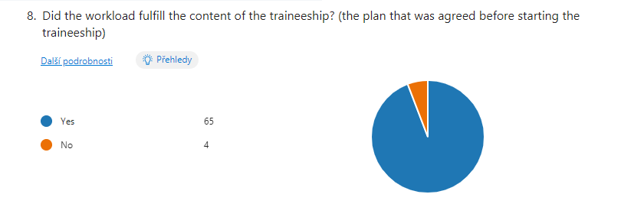

The field of the traineeship of the participants varies a lot but in general, were business or services oriented. More details can be found in the picture below.
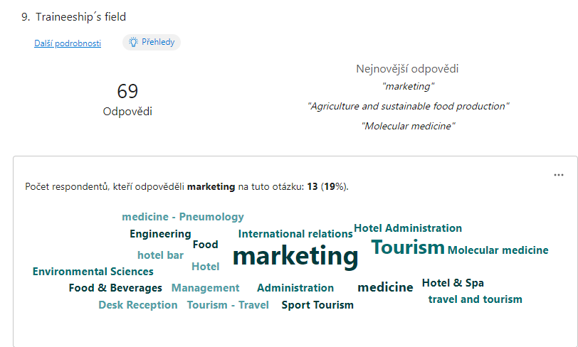

Half of the trainees confirm that they have gotten some sort of salary for their work and 53 of the participants agreed that the traineeship was beneficial for their future carrier. On the other hand, only half of the participants assume that the written evaluation of the traineeship helped them with their job application. The majority of the trainees confirm that they improved their language skills, improved intercultural competencies as well as learned about the company´s internal system, and could work independently. Participants agreed that it was full-time work and 40 participants out of the 69 could not work remotely but had to participate on face to face in office work.
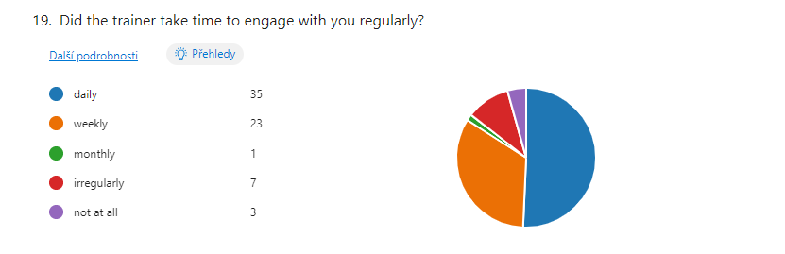
The final questions are dedicated to the evaluation of the traineeship and the quality criteria in particular. 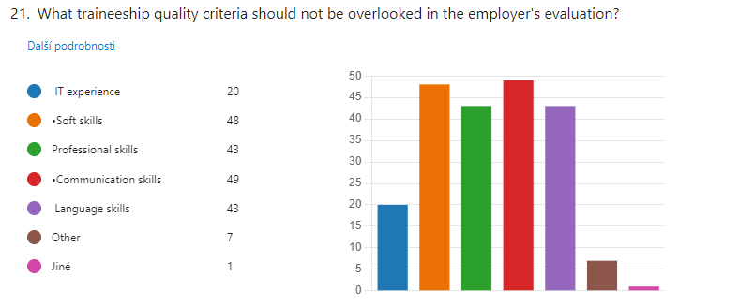

Survey for companies:
The survey for companies was much more difficult to distribute in sense of persuading the company employees to save time by filling it in. The average time for the survey filling in was 6 minutes nevertheless only 13 companies have submitted their answers.
Even though the return of replies is rather low the institutions/companies were of different scales and sectors of involvement hence even such number of participants is giving sort of picture of the perceptions of the companies. The company’s sector of involvement varies from education and culture to medicine or consulting and management or agriculture. Half of the companies were of micro companies scale and 3 of them were describing themselves as large-scale companies employing more than 250 people.
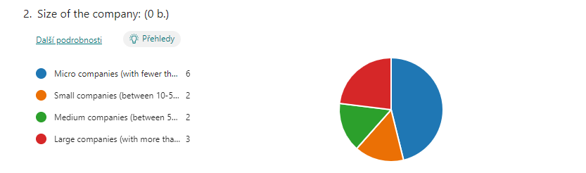

Two of those participating companies were from Austria and two were from Poland the rest represents a variety of EU countries such as Finland, Cyprus, Italy or the Czech Republic. The survey emphasizes what the company’s representatives consider as vital skills for trainees to have and which skills the trainees usually lack. The answer to the first what the trainees shall possess as a requirement given by the company are usually English language, basic IT skills, and field-specific information/knowledge. On the other hand the trainees usually lack industry knowledge, and work skills such as teamwork skills and language skills.
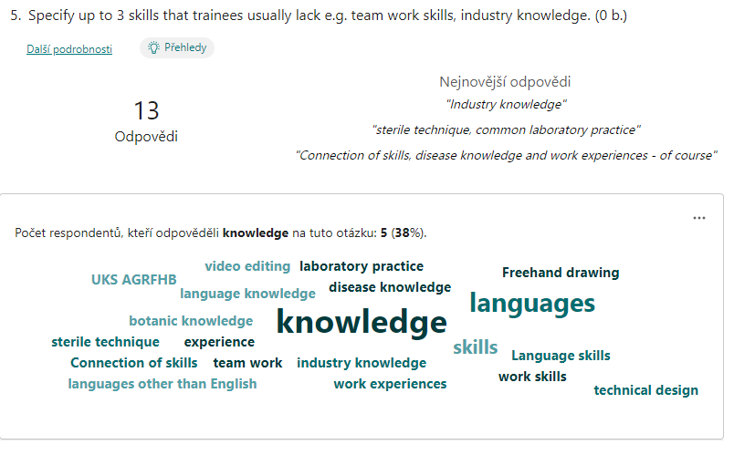

Based on this perception the trainers usually answer that they do not lead the trainees to work independently hence the trainees worked only occasionally independently. The majority of the companies (9) answered that they used to give feedback daily or weekly in the form of oral evaluation. The majority of companies, except one, give no salary to the trainees but some of them provide them with free meals or even accommodation free of charge.

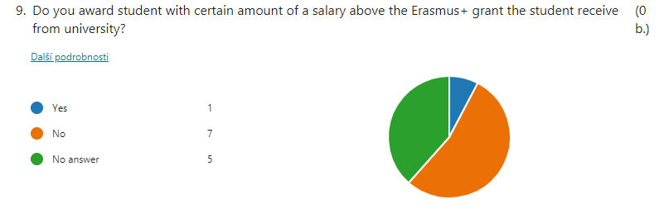
When it comes to the willingness of the companies to hire the trainees and their employees 8 of them would hire them and 5 of them would not hire the employee.

6. Recommendations
As a result of the analysis of questionnaires, an Erasmus evaluation form was created for the evaluation of trainees in institutions. The Traineeship Evaluation Form has two forms, while they are identical in content, electronical version available on: https://educaops.eu/cs/projekty-erasmus/aqet-2/

Option 1:

EVALUATION OF THE TRAINEE
TRAINEE NAME:
UNIVERSITY:
ORGANISATION NAME:
COUNTRY:
DETAILED SUMMARY OF STUDENT’S WORK:

TRAINEESHIP PERIOD FROM ________________ TO_______________

RATING SYSTEM – Please rate the intern’s performance using the following 0-4 scale.
4 – excellent, / highly satisfactory
3 – satisfactory/ good
2 – fair / average
1 – unsatisfactory
0 – N/A
Personal Evaluation

 | 4 | 3 | 2 | 1 | 0 | COMMENTS
1. LEVEL OF KNOWLEDGE IN THE FIELD
2. ABILITY TO APPLY THEORETICAL KNOWLEDGE IN PRACTICE
3. USE OF ICT TOOLS
4. COMMUNICATION SKILLS,ORAL AND WRITTEN EXPRESSION
5. EFFICIENCY
6. ORGANIZATION SKILLS
7. INTEREST IN NEW KNOWLEDGE, ABILITY TO LEARN
8. KNOWLEDGE OF FOREIGN LANGUAGES

Professional Skills and Qualification
 | 4 | 3 | 2 | 1 | 0 | COMMENTS
1. RELATIONSHIP WITH SUPERIORS
2. COMMUNICATION WITH CLIENTS
3. SOCIAL MEDIA / SOFTWARE SKILLS
4. RECEIVING CRITICISM
5. ADAPTABILITY
6. REGULAR ATTENDANCE
7. INDEPENDENCE
8. RESPONSIBILITY
9. ABILITY OF TEAMWORK
OVERALL RATING OF THE TRAINEE

INTERN’S MAIN STRENGHTS | RECOMENDATIONS FOR IMPROVEMENT

Overall performance rating:

This assessment has been discussed with the student: YES/NO
If you had a position available, would you offer the student a job: YES/NO

Date and Supervisor signature:

This form must be presented to the trainee or to the sending institution(consortium in the original version!

Option 2:

EVALUATION OF THE TRAINEE

TRAINEE NAME:
UNIVERSITY:
ORGANISATION NAME:
COUNTRY:
DETAILED SUMMARY OF STUDENT’S WORK:

TRAINEESHIP PERIOD FROM ________________ TO_______________

RATING SYSTEM – Please rate the intern’s performance using the following 0-4 scale.
4 – excellent, / highly satisfactory
3 – satisfactory/ good
2 – fair / average
1 – unsatisfactory
0 – N/A

Personal Evaluation
 | RATING | COMMENTS
1. LEVEL OF KNOWLEDGE IN THE FIELD
2. ABILITY TO APPLY THEORETICAL KNOWLEDGE IN PRACTICE
3. USE OF ICT TOOLS
4. COMMUNICATION SKILLS,ORAL AND WRITTEN EXPRESSION
5. EFFICIENCY
6. ORGANIZATION SKILLS
7. INTEREST IN NEW KNOWLEDGE, ABILITY TO LEARN
8. KNOWLEDGE OF FOREIGN LANGUAGES

Professional Skills and Qualification
 | RATING | COMMENTS
1. RELATIONSHIP WITH SUPERIORS
2. COMMUNICATION WITH CLIENTS
3. SOCIAL MEDIA / SOFTWARE SKILLS
4. RECEIVING CRITICISM
5. ADAPTABILITY
6. REGULAR ATTENDANCE
7. INDEPENDENCE
8. RESPONSIBILITY
9. ABILITY OF TEAMWORK
OVERALL RATING OF THE TRAINEE

INTERN’S MAIN STRENGHTS | RECOMENDATIONS FOR IMPROVEMENT

Overall performance rating:

This assessment has been discussed with the student: YES/NO

If you had a position available, would you offer the student a job: YES/NO

Date and Supervisor signature:

This form must be presented to the trainee or to the sending institution (consortium) in the original version!

Part 2

Erasmus Guide for Institutions

Traineeships in Institutions
The implementation of traineeships for students or university graduates in institutions (companies) abroad brings many advantages for both parties, as the trainees gain practical experience in the field of study, and for institutions this means obtaining workers/trainees for free. Although they are not experienced experts, it is possible to use their theoretical knowledge and involve them in the activities of the institution.
However, this requires activities aimed at supporting interns as part of their inclusion in the work team of the institution, gradual induction and continuous control of the activities performed. Taking care for trainees is a significant investment in each trainee, as they are not legally entitled to wages. Living expenses are supported from the Erasmus+ programme. However, there are institutions that, in addition to the grant, provide wages for work performed, or for work beyond the scope of the defined working hours, for night work or for work on days off (e.g. medical staff).
The success of the implementation of internships is derived from those foreign institutions that are interested in the active involvement of students and university graduates. The institution must be proactive before accepting trainees and must be interested in training real professionals rather than recruiting cheap labour for low-skilled positions. Institutions that are active in the joint preparation of the so-called "Learning Agreement for Traineeship" and its subsequent compliance are suitable for trainees. Therefore, it is necessary to specify in details the purpose and objectives of the traineeship that the universities require.
Every foreign institution accepting trainees must take into account possible risks and how to prevent them - interns are foreigners whose knowledge of language or culture may not be at the highest level, and therefore it is necessary to work with them especially in the first days and weeks after starting the traineeship. A trainer/tutor should be designated here for the full integration of interns into the activities of the company/institution and for monitoring their activities. This support should also include support outside working hours (help them with accommodation, consultation in solving personal problems).
The work of trainees must be continuously monitored and evaluated. The subject of evaluation is not only work results, but the overall involvement of trainees in the work team and their social skills. Critical comments should be given to trainees in such a way that they do not discourage them from the activity being performed, but to motivate them to achieve better results.
The working hours of interns are determined in the range of full working hours valid in the countries where the traineeships are carried out. It is not possible to require work beyond the set working hours. In the same way, it is necessary to respect the days off and holidays in the given country. Any activity outside working hours or work on non-working days is voluntary and trainees should be paid or given the opportunity to take compensatory time off.

Trainees have a grant to stay abroad during the whole traineeship period (even if they work online in that country). However, online work must be part of the internship contract. If the trainees are working online and stay in their home country, they are not eligible for the grant. The host institution is under no obligation to provide wages for work performed to trainees. However, it is possible to provide a wage (e.g. the minimum wage set in the country) and this does not reduce the grant awarded.

Evaluation of Trainees
The evaluation of the traineeship performance must be evaluated by the institution after the end of the traineeship, and the evaluation must be given to the trainees, or subsequently sent to the university or consortium with an original confirmation from the representative of the institution (it can also be a tutor or another person acting on behalf of the institution). This document, in its original form, also serves as proof of eligibility for drawing the allocated grant, and without it any traineeship can be completed and award an allocated grant.
The evaluation of trainees is very important for the sending university for compulsory (or optional) traineeships and the allocation of credits (ECTS) recognized for academic results.
For students and especially for graduates, the assessment is important for documenting previous practical experience when looking for a job, and therefore an assessment of not only the professional knowledge, but also the soft skills of the trainee is required.
In order for such an evaluation to meet the conditions required by universities and students or graduates, great attention must be paid to the processing of the final evaluation of trainees. The evaluation must have informative value, and in order not to burden the institution with an institutional description, a simple form has been developed, which he fills in according to the experience he gained during the traineeship.
The evaluated trainees should be made aware of the evaluation and should have the opportunity to comment on it if you consider it necessary.

Presentation of the Erasmus+ Traineeship Programme for Institutions

