EXPROM: Dissemination materials from partner institutions
ExPrOM - DISSEMINATION ACTIVITIES – UNIVERSITY OF VAASA, FINLAND
BEFORE THE PROJECT WAS APPROVED
2017 OCTOBER
– Informing the team (5 people) and the unit (25 people) in team/unit meetings about the contacts made on a TCA and the project draft written with the partners and the topics to be dealt.

DURING THE LIFETIME OF THE PROJECT
2018 AUGUST
– Informing the team (5 people) in a team meeting about the decisions made on the kickoff meeting and the work to be done.
2018 NOVEMBER/DECEMBER
– Informing the team (5 people) and the unit in team/unit meetings about the exchange in Slovenia, and brainstorming on how to utilise the lessons learned in our own activities.
2019 MARCH/APRIL
– Informing the team (8 people) and the unit (25 people) in team/unit meetings about the exchange in Spain, and brainstorming on how to utilise the lessons learned in our own activities.
2019 APRIL/MAY
– Contacting local employment officials and other stakeholders and discussing the goals and achievements (this far) of the project.
2019 JUNE
– Posts on our Social Media Profiles about ExPrOM 3RD mobility held in Finland.
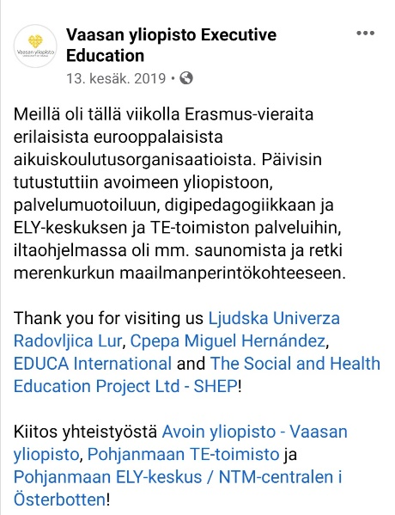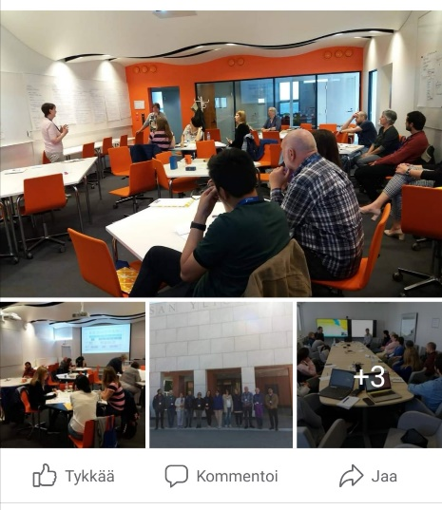
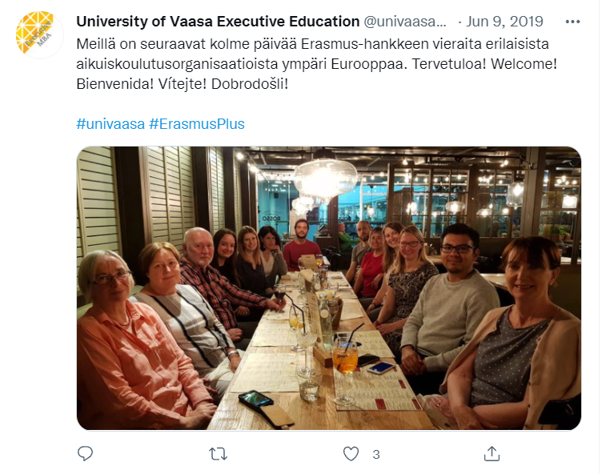
– Informing the team (8 people) and the unit (25 people) in team/unit meetings about the exchange in Finland and activities organised.
2019 NOVEMBER
– Informing the team (8 people) and the unit (25 people) in team/unit meetings about the exchange in the Czech Republic, and brainstorming on how to utilise the lessons learned in our own activities.
2021 JUNE
– Informing the team (10 people) and the unit (25 people) in team/unit meetings about the online workshop by the Irish partner, and brainstorming on how to utilise the lessons learned in our own activities.

LONG TERM WORK ON THE PROJECT
2021 SEPTEMBER AND ON
– The university keeps on developing pedagogy and learning methods to be more versatile and inclusive. The Continuous learning unit applies for new domestic and international projects that aim in creating more studying opportunities for all.

ExPrOM - DISSEMINATION ACTIVITIES – CPEPA MIGUEL HERNÁNDEZ (HUESCA) SPAIN
BEFORE THE PROJECT WAS APPROVED
2017 OCTOBER
– Staff meeting (25 people) to inform about the contacts made on a TCA and the project draft written with the partners and the topics to be dealt.
– PRESS RELEASE sent to written and digital local media about our participation on the TCA in Dublin that fostered the contact with the partners and where the first project draft was written, describing the objectives, the work to be done and possible impact in our school and educational community.
– PRESS REPORT on Local Newspaper (Diario del Altoaragón) based on the previous press release.
– Posts on our website and Social networks Profiles (Facebook, Twitter and Instagram) related to the TCA and the contacts made and the project draft. Tagging our National Agency (#SEPIE), #EPALE (adult learning organisation), #EPAAragon (Regional adult learning Educational Organization) and #erasmusplus.
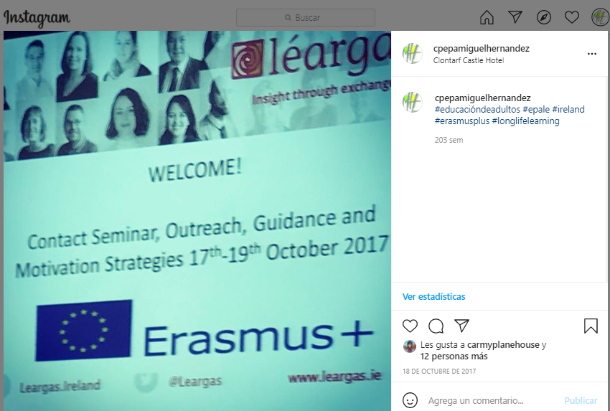
2018 JANUARY
– Phone contacts and short interviews with directors from 10-12 Educational Organisations, informing them about the project application, the activities and their possible cooperation and participation in it.

DURING THE LIFETIME OF THE PROJECT
2018 JULY
– Posts on our website and Social Networks when ExPrOM was approved.
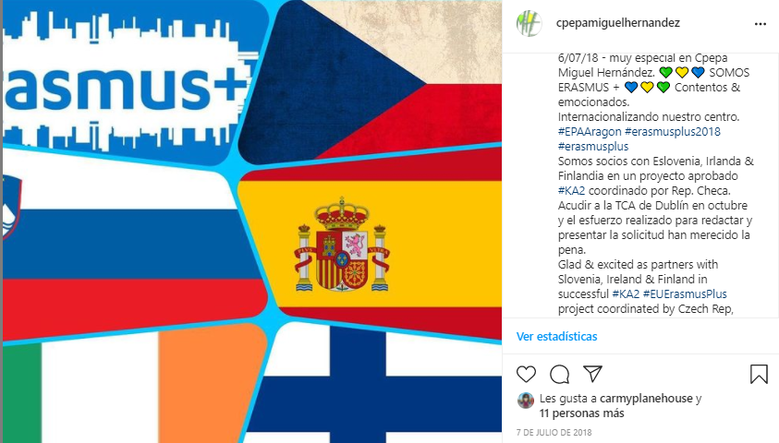
2018 SEPTEMBER
– Posts on our website and Social Networks about ExPrOM kick off meeting in Prague.
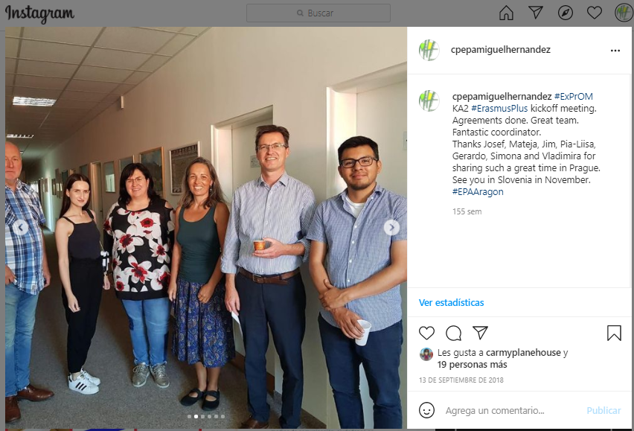
– STAFF MEETING (25 people) to inform about the decisions made on the kickoff meeting and the work to be done.
– Press release sent to written and digital local media on the kickoff meeting and press report on local newspaper (Diario del Altoaragón)
2018 NOVEMBER
– Posts on our website and Social Networks Profiles about ExPrOM 1ST mobility in Slovenia.
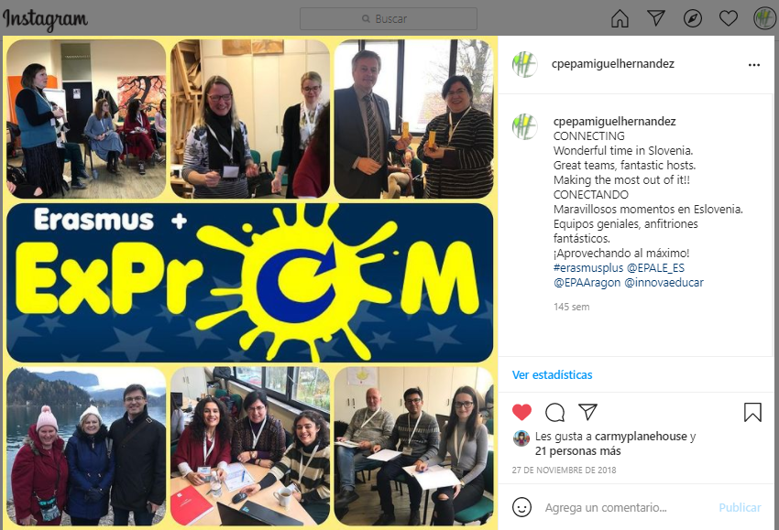
– STAFF MEETING (25 people) to inform about the exchange in Slovenia, which included a written report on the activities done during the mobility and a slide presentation.
– Press release sent to written and digital local media on the Slovenia mobility and press report on local newspaper (Diario del Altoaragón)
2019 JANUARY
– Informative talk held in the CIFE (Centro de Innovación y Formación Educativa – Innovation and Training Educational Centre) in Huesca sharing our experience so far in the KA2 ExPrOM project, around 15 people attended it, mainly teachers from adult education organisations as well as local primary and secondary school teachers, who later on we assume reported on their organisations.
– Posts on our Social Networks Profiles about this informative talk.
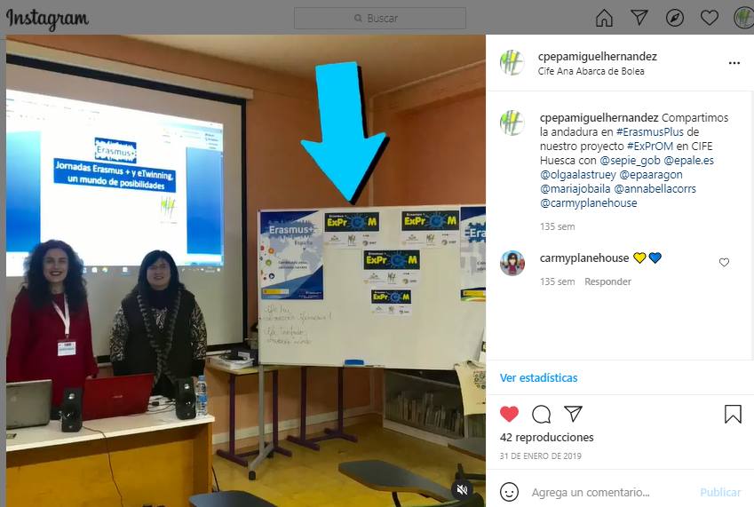
2019 MARCH
– Posts on our website and Social Media Profiles about ExPrOM 2nd mobility held in Huesca (SPAIN).
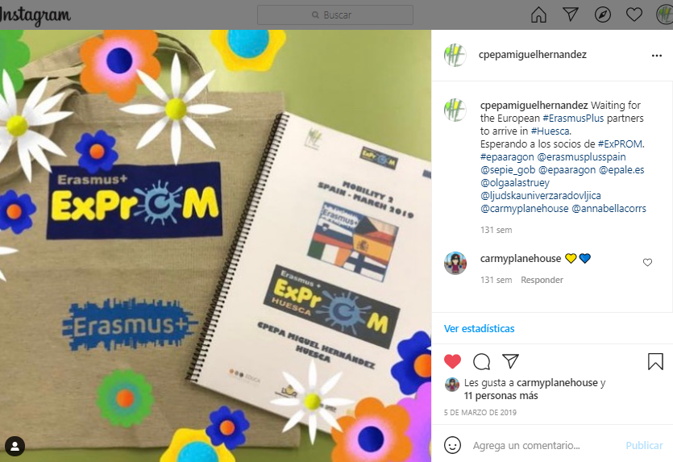
– STAFF and LEARNERS MEETINGS to inform about every activity done during the exchange in Spain, which included written reports and presentations.
– Leaflets and posters on ExPrOM displayed all over our school building.
– Press release sent to written and digital local media on the Spain mobility and press report on local newspaper (Diario del Altoaragón).
2019 JUNE
– Posts on our website and Social Media Profiles about ExPrOM 3RD mobility held in Finland.
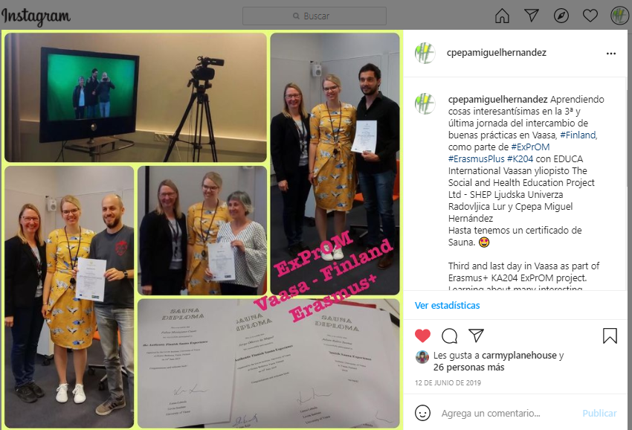
– STAFF MEETING (25 people) to inform about the exchange in Finland, which included a written report on the activities done during the mobility and a slide presentation.
– Press release sent to written and digital local media on the Finland mobility and press report on local newspaper (Diario del Altoaragón).
2019 NOVEMBER
– Posts on our website and Social Media Profiles about ExPrOM 4TH mobility held in Czech Republic.
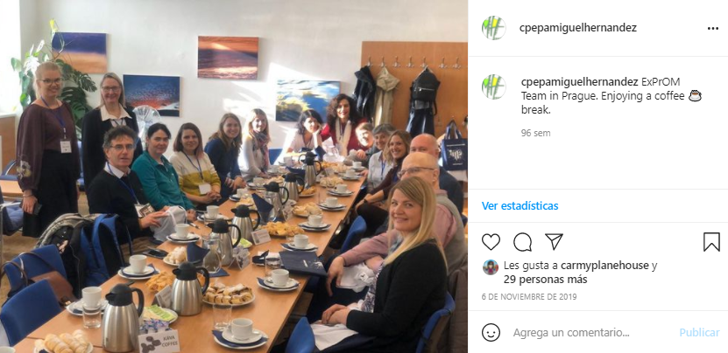
– STAFF MEETING (25 people) to inform about the exchange in the Czech Republic, which included a written report on the activities done during the mobility and a slide presentation.
– Press release sent to written and digital local media on the Czech mobility and press report on local newspaper (Diario del Altoaragón).
2019 DECEMBER
– Informative talk held in the CIFE (Centro de Innovación y Formación Educativa – Innovation and Training Educational Centre) in Huesca sharing our experience so far in the KA2 ExPrOM project, around 15 people attended it, mainly teachers from adult education organisations as well as local primary and secondary school teachers, that later on we assume reported on their organisations.
– Posts on our Social Networks Profiles about this informative talk.
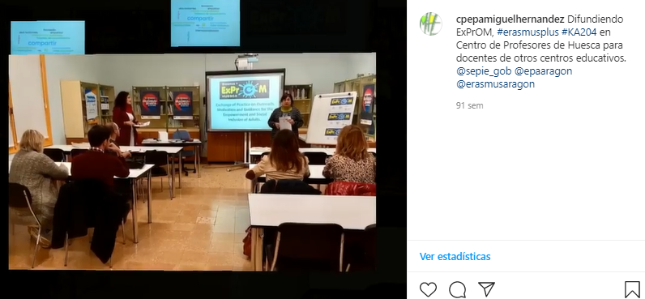
2020 FEBRUARY
– Informative talk about our experience in ExPrOM and the aspects developed so far, held in our school in Huesca as part of the MIRA y ACTÚA educational exchange programme called by the regional educational authorities. Around 10 people attended it, mainly teachers from other adult education organisations, language school teachers, staff from the CIFE (Centro de Innovación y Formación Educativa – Innovation and Training Educational Centre) and regional educational authorities.
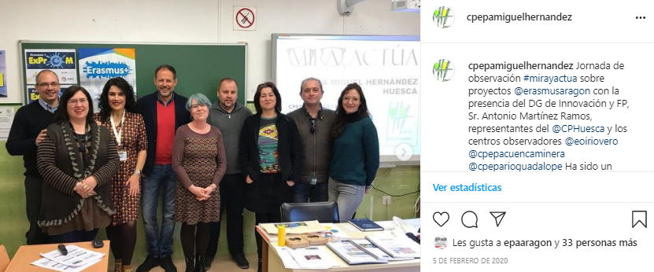
– Posts on our social media profiles on the talks.
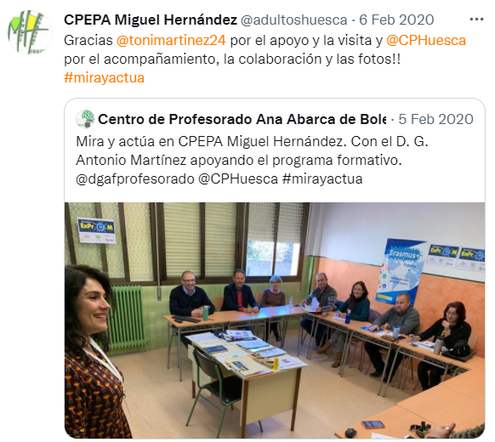
2021 MAY
– ERASMUS CORNER DISPLAY on a notice board at the school entrance which included some printed materials on ExPrOM.
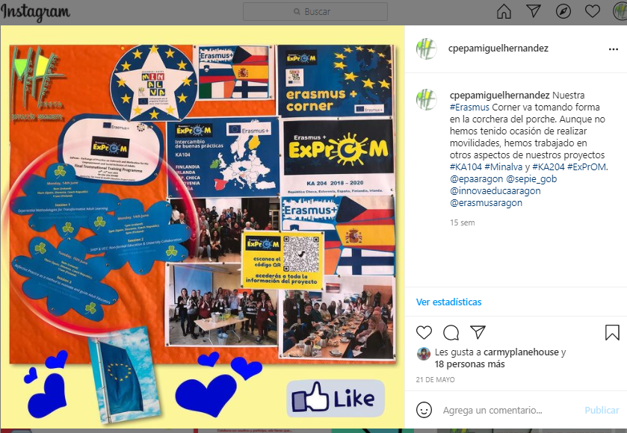
– Email and phone contact with some people working for organisations from Navarra working on a project (FORLAN) similar to ExPrOM to exchange information.
2021 JUNE
– Posts on our website and Social Media Profiles about ExPrOM 5TH mobility held online via Zoom and coordinated by the Irish team in Cork.
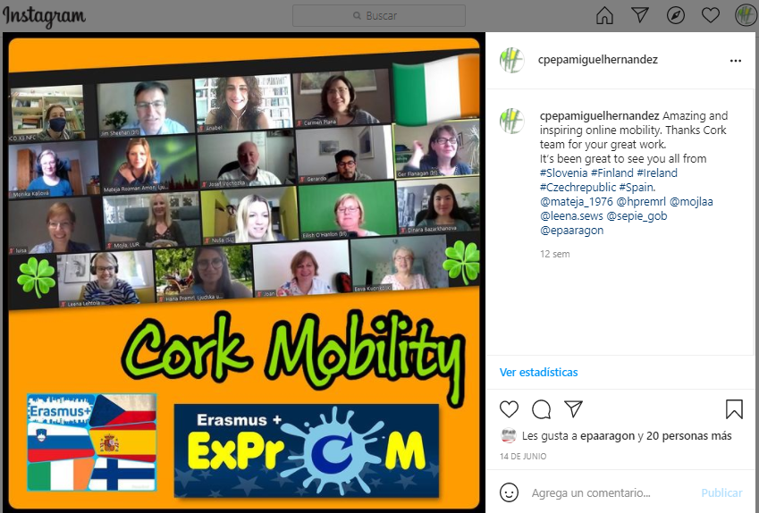
– STAFF MEETING (25 people) to inform about online mobility from Ireland, which included information on the activities done during the online presentations.
– ONLINE MEETING with 3 FORLAN representatives from Navarra to share our experience in the project, present them some of our ExPrOM results and exchange ideas.
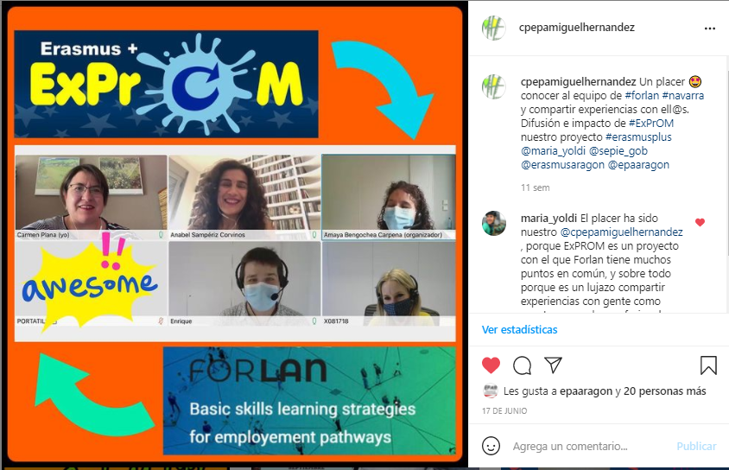
–ExPrOM LINK in our school’s website has been regularly updated during the project. https://sites.google.com/view/exprom/inicio-home

LONG TERM WORK ON THE PROJECT
2021 SEPTEMBER AND ON
–ExPrOM website will be kept and updated if needed after the project, so the results and activities can be accessed by anyone.
– ERASMUS CORNER DISPLAY on the notice board at the school entrance, which included some printed materials on ExPrOM, will be displayed for some more months.
– We will attend seminars organised by CIFE, or by the Teacher Training Faculty of Education (Spain), where we will be glad to present the results of ExPrOM, the changes it generated and our experience in this type of projects.
– We will also provide future training to staff members to ensure methodologies and tools learnt are easily replicated and used in real work experiences.
– We will write a wrapping report on the project and send it to EPALE to be posted on their blog.

ExPrOM - DISSEMINATION ACTIVITIES – LJUDSKA UNIVERZA RADOVLJICA (SLOVENIA)
BEFORE THE PROJECT WAS APPROVED
2017 OCTOBER
– Staff meeting (14 people) to inform about the contacts made on a TCA and discussion about the project proposal that was made between the five partners (Spain, Czech, Ireland, Finland, Slovenia).
– description of our participation on the TCA in Dublin in local digital media, LUR website and FB profile
2018 JANUARY
– Staff meeting 0ith the leaders of different educational programmes in Ljudska univerza Radovljica and Phone contacts and short interviews with directors from 10-12 Educational Organisations, informing them about the project application, the activities and their possible cooperation and participation in it.
All of the activities in the project are available on our website: Erasmus+ ExPrOM - Ljudska Univerza Radovljica (lu-r.si)

DURING THE LIFETIME OF THE PROJECT
2018 JULY
– Posts on our website and Social Networks when ExPrOM was approved.
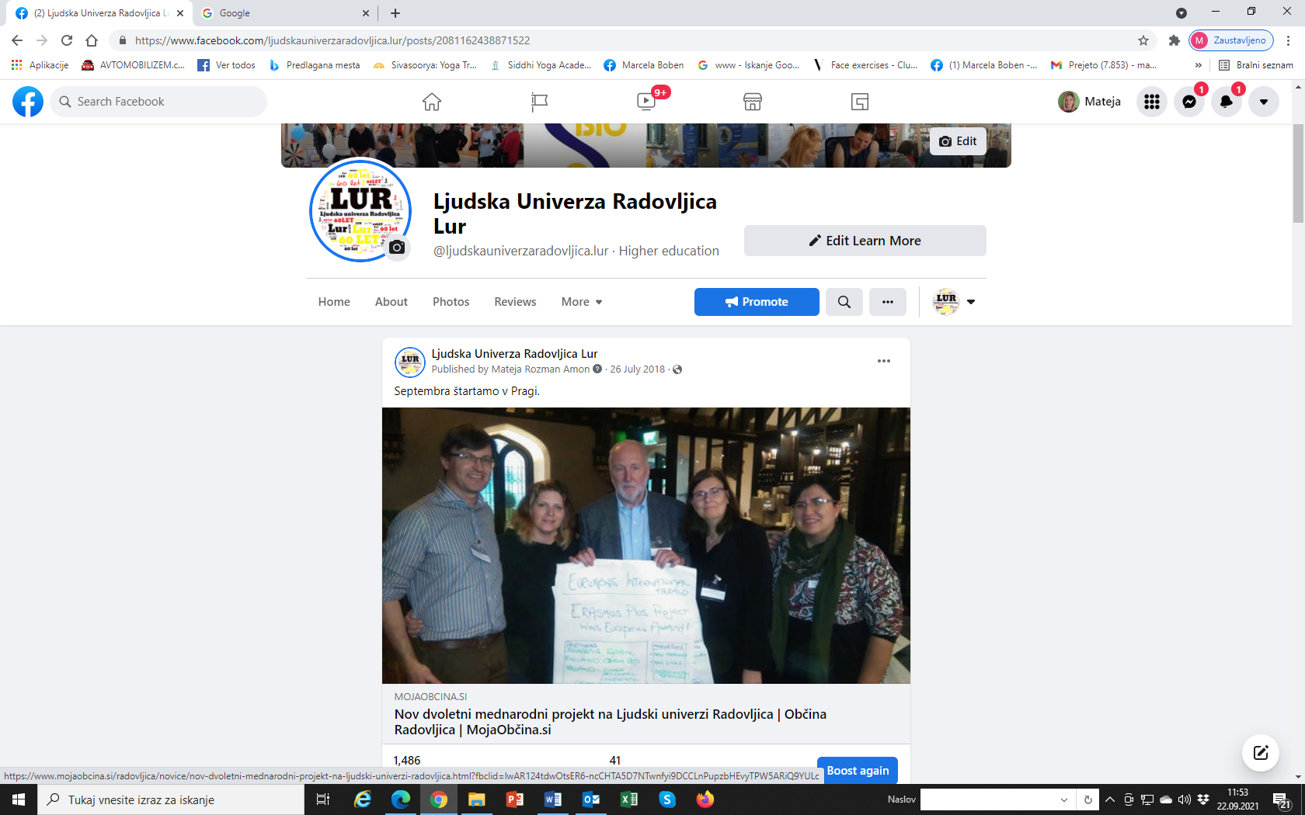

2018 SEPTEMBER
– Posts on our website and Social Networks about ExPrOM kick off meeting in Prague.

– STAFF MEETING (14 people) to inform about the decisions made on the kickoff meeting and the work to be done.
2018 NOVEMBER
– Posts on our website and Social Networks Profiles about ExPrOM 1ST mobility in Slovenia.
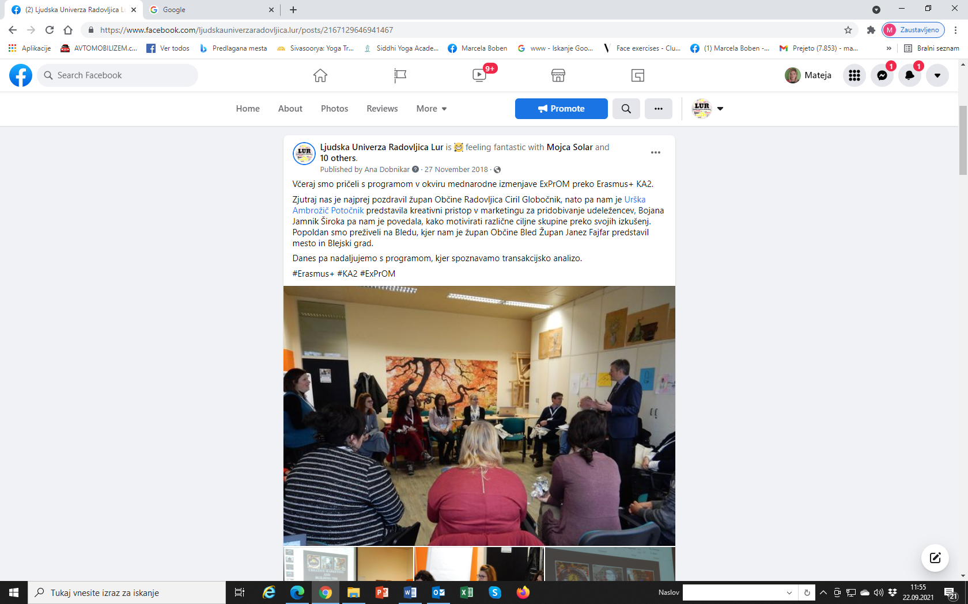

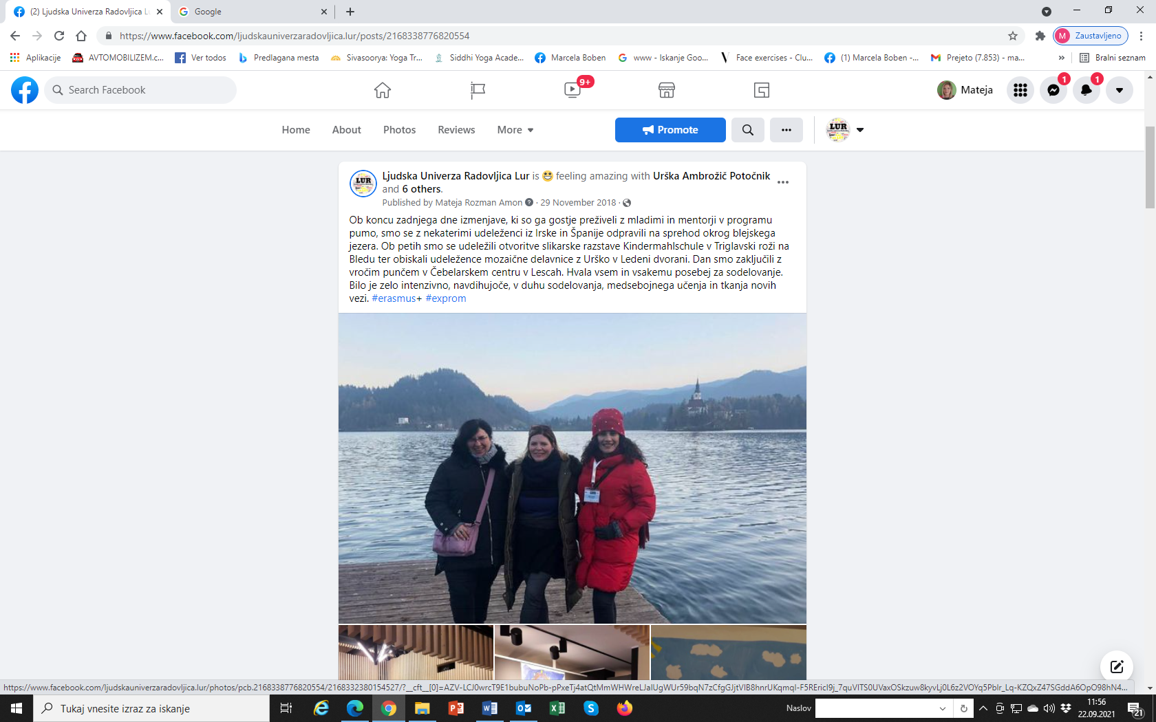
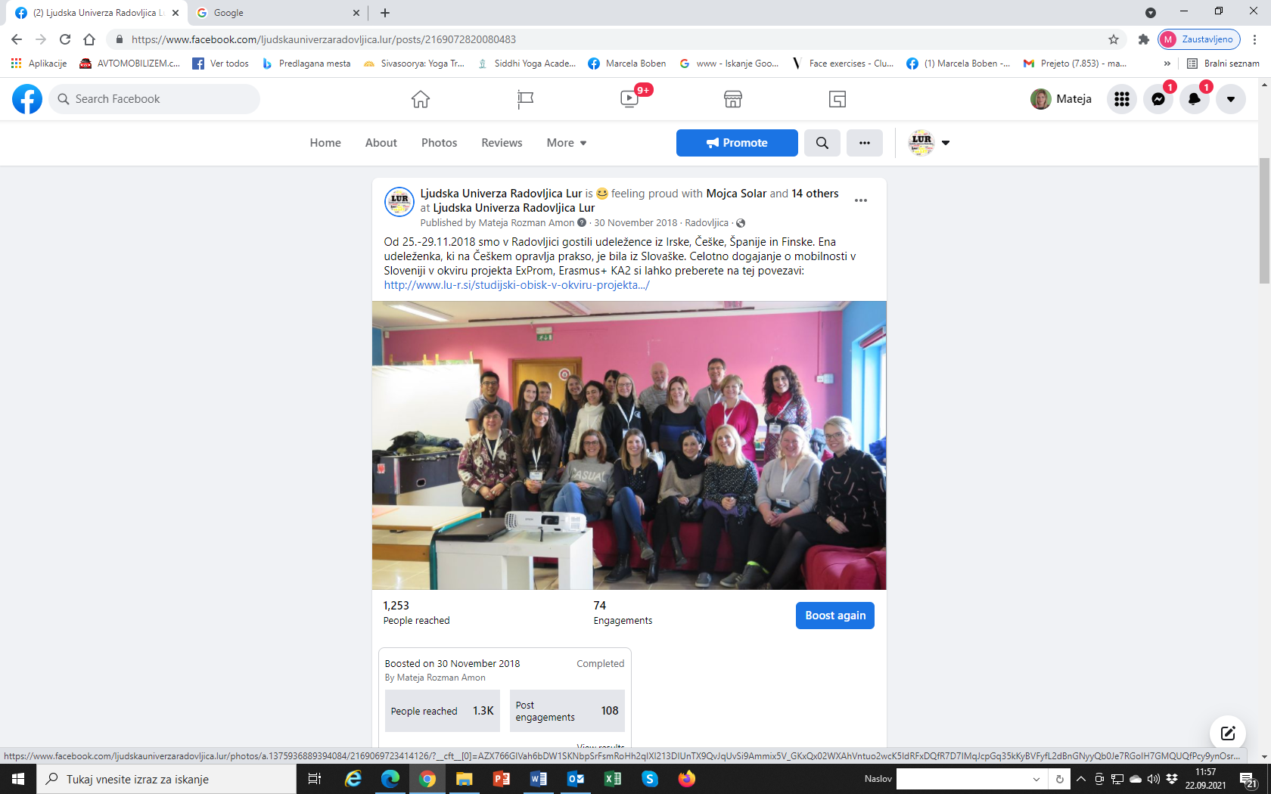
- STAFF MEETING (14 people) to evaluate the exchange in Slovenia, which included all the activities involved, participants who were cooperating in learning activities and in organisation of the meeting
2019 MARCH
– Posts on our website and Social Media Profiles about ExPrOM 2nd mobility held in Huesca (SPAIN).
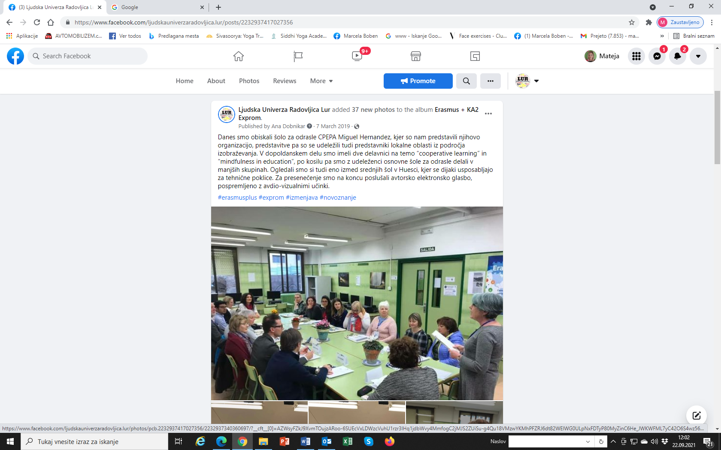
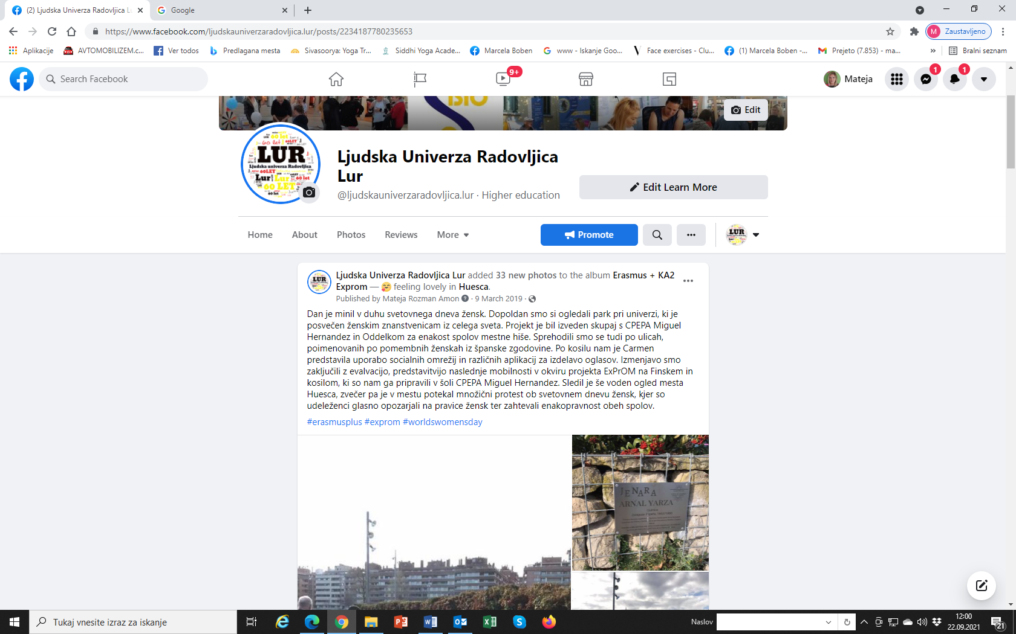
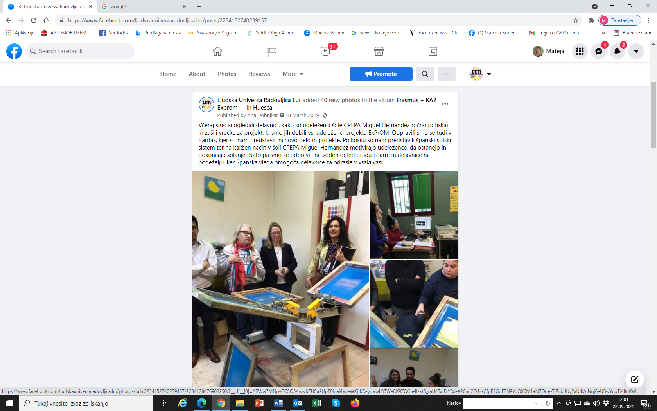
- STAFF and external teachers meeting to inform about every activity done during the exchange in Spain
2019 JUNE
– Posts on our website and Social Media Profiles about ExPrOM 3RD mobility held in Finland.
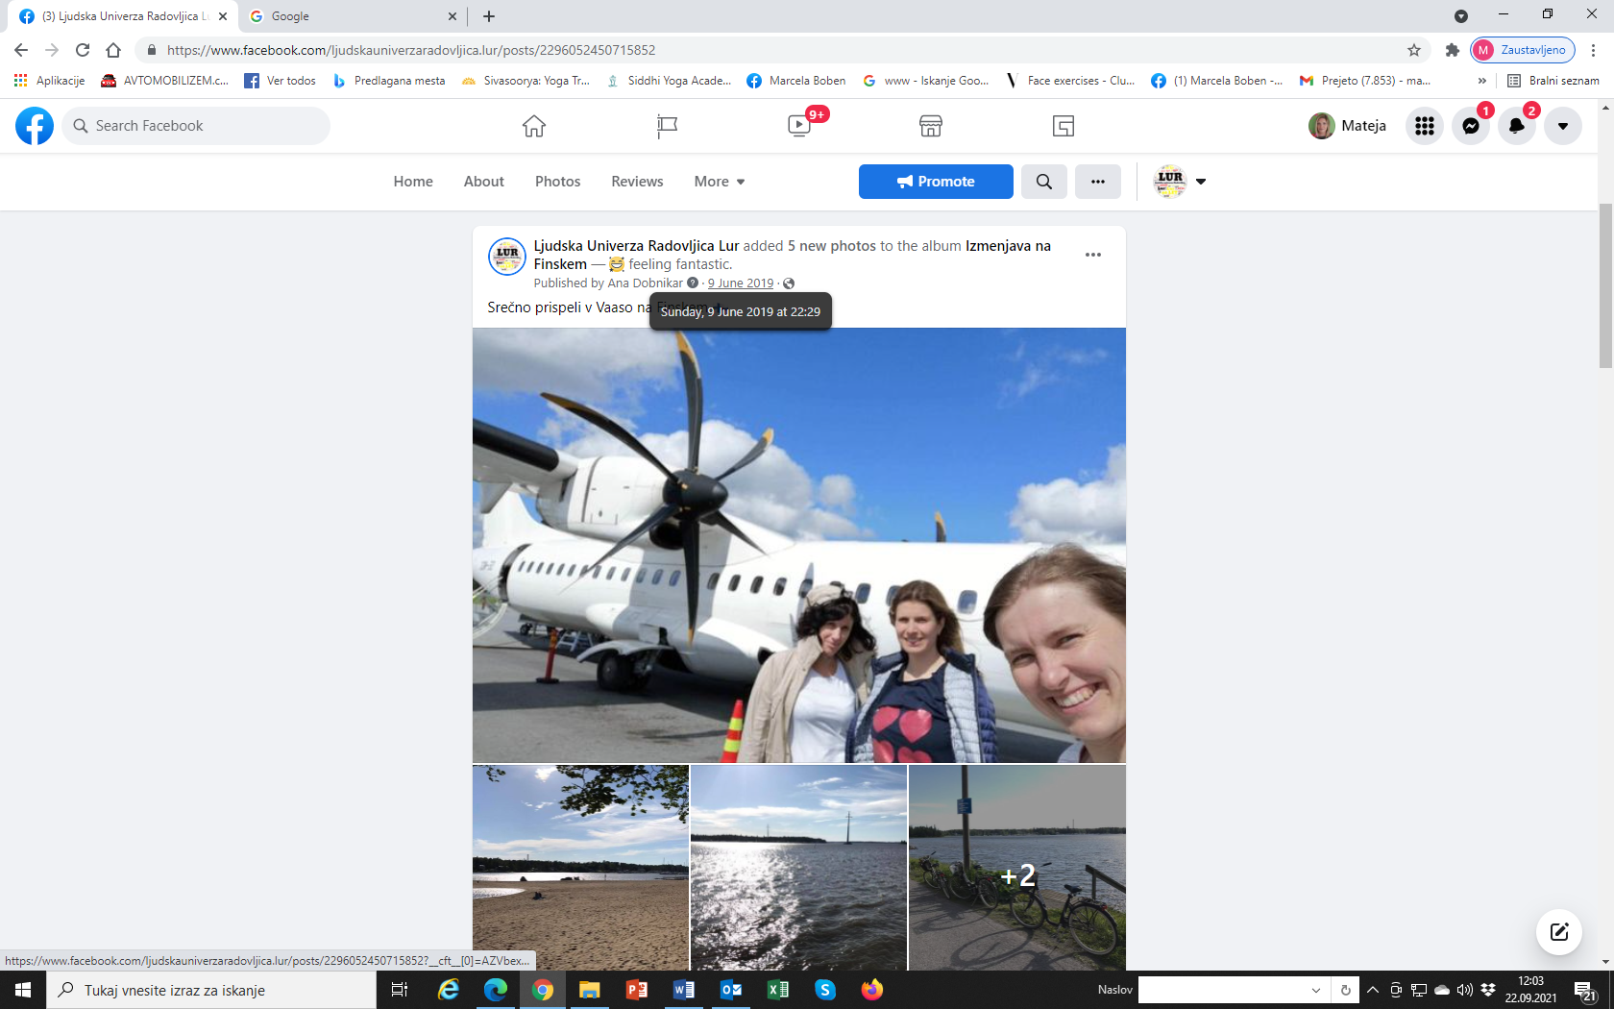
– STAFF MEETING (14 people) to inform about the exchange in Finland, which included a written report on the activities done during the mobility and a slide presentation.

2019 OCTOBER
Informative talk about our experience in ExPrOM and the aspects developed so far, held in Ljudska univerza Radovljica. Around 50 people attended it, mainly teachers that do contract work with us and also teach in other schools and adult education organisations. We presented the project in this meeting that is held once a year with all employees and external co-workers.
2019 NOVEMBER
– Posts on our website and Social Media Profiles about ExPrOM 4TH mobility held in Czech Republic.
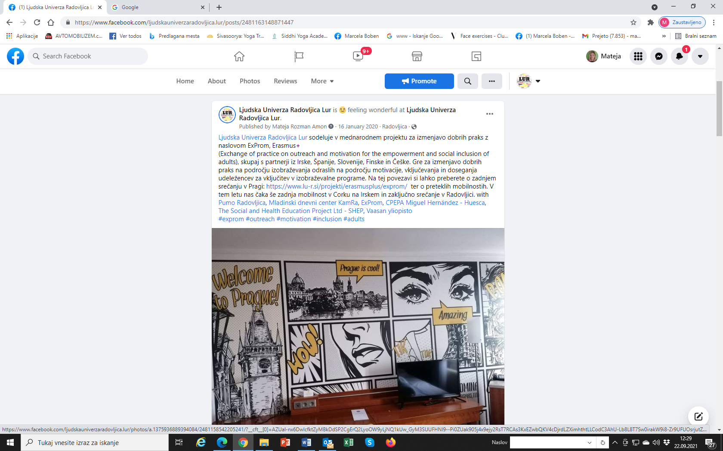
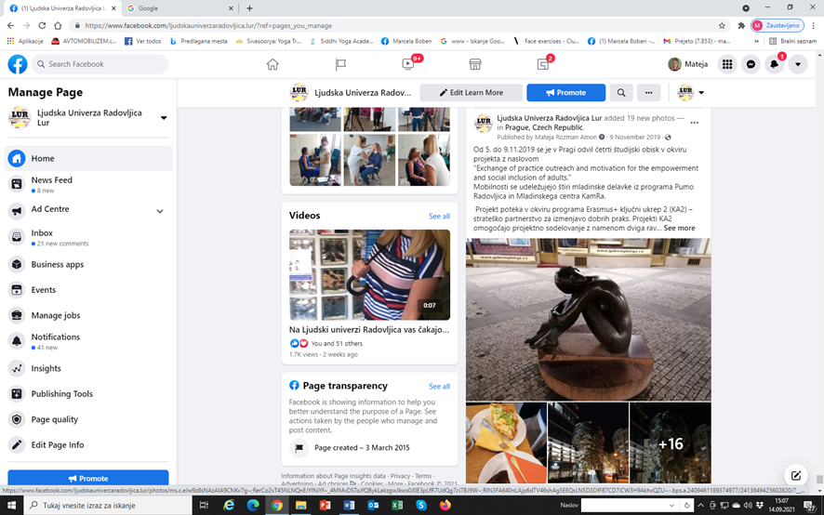

– 2019 STAFF MEETING (14 people) to inform about the exchange in the Czech Republic, which included a written report on the activities done during the mobility.
2020 FEBRUARY
– Informative talk about our experience in ExPrOM and the aspects developed so far, held in Ljudska univerza Radovljica. Around 10 people attended it, mainly teachers from other schools and adult education organisations.
APRIL 2021
Informative talk after online meeting with all the partners where decsion was made that we are not going to travel to Cork. We overviewed all the project with the staff and decided who will participate in the online meeting.

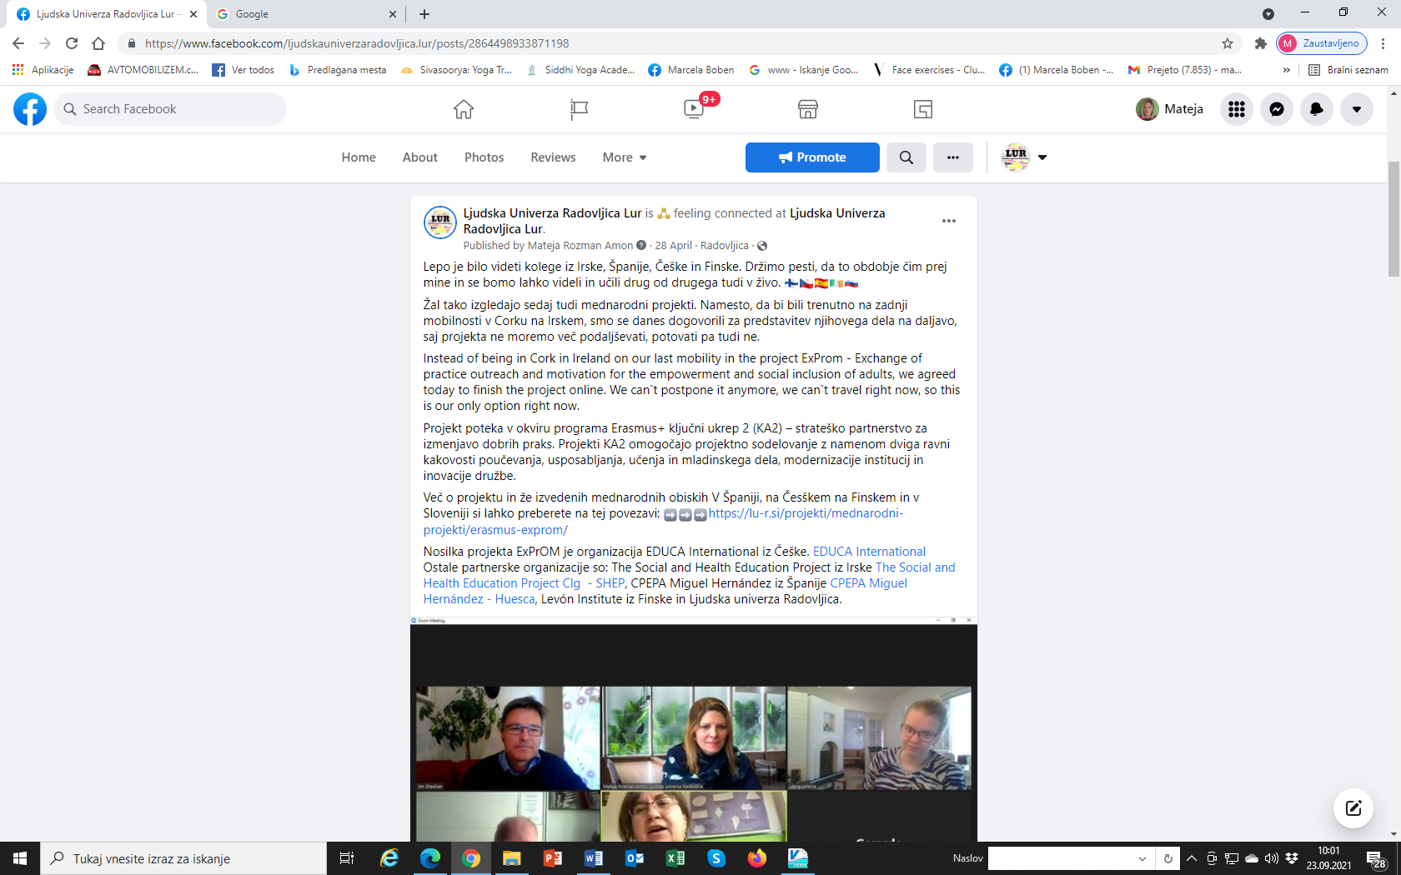

– Email and phone contact with some people working for organisations from Navarra working on a project (FORLAN) similar to ExPrOM to exchange information.
2021 JUNE
– Posts on our website and Social Media Profiles about ExPrOM 5TH mobility held online via Zoom and coordinated by the Irish team in Cork.

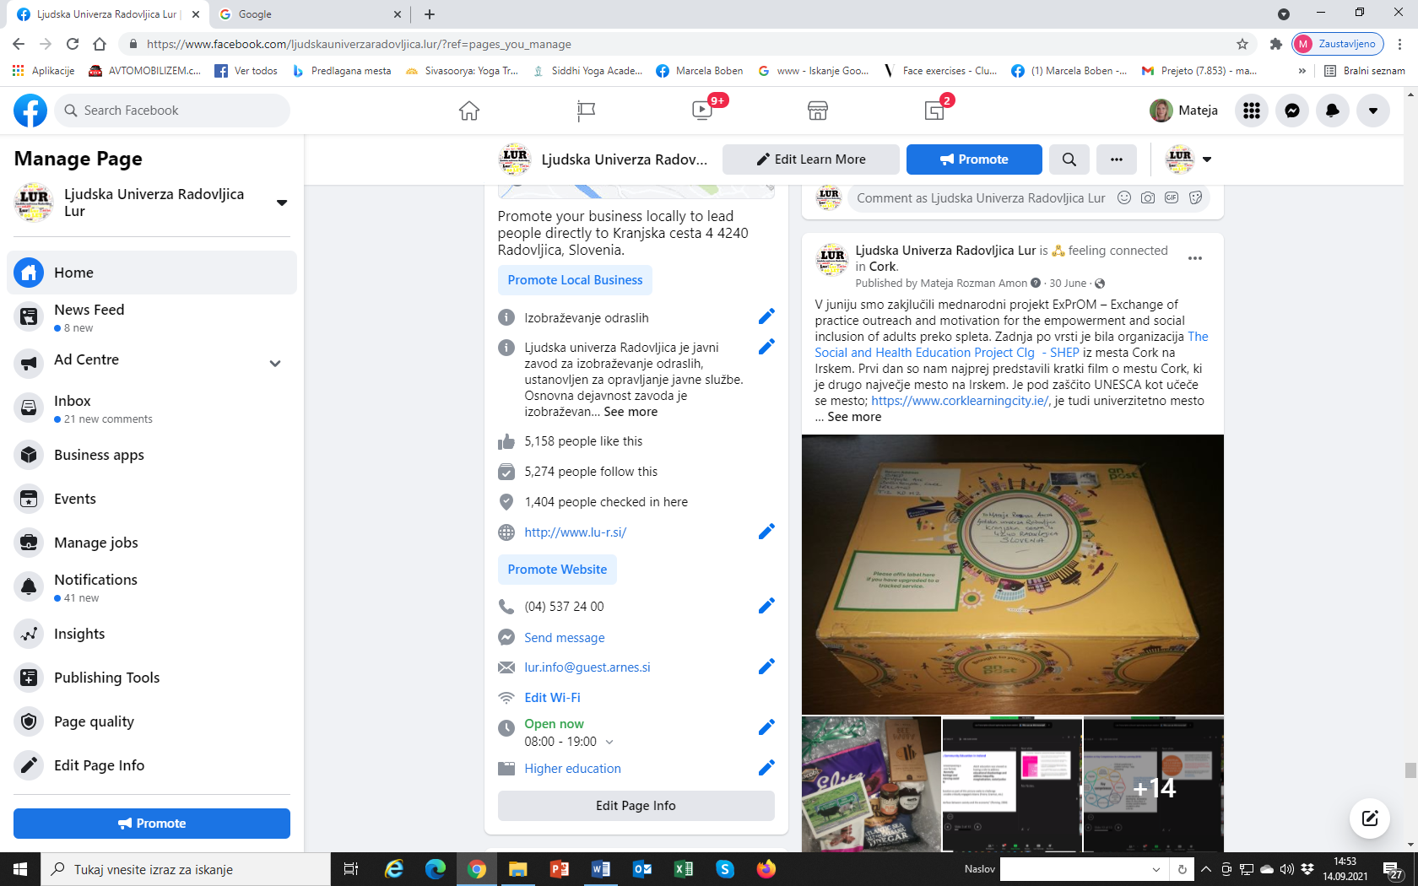
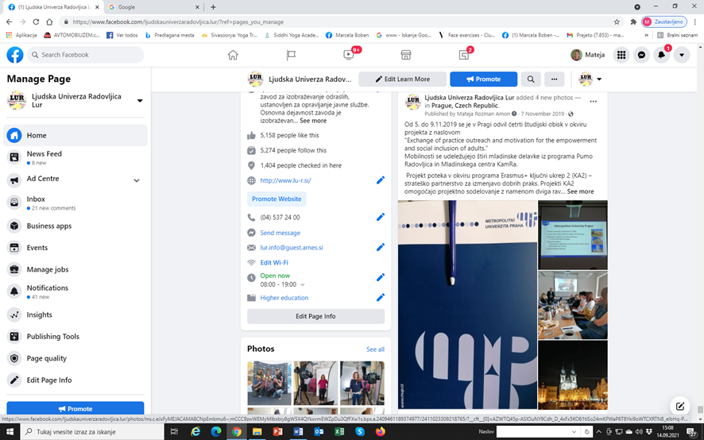
– STAFF MEETING (14 people) to inform about online mobility from Ireland, which included information on the activities done during the online presentations.
LONG TERM WORK ON THE PROJECT
2021 SEPTEMBER AND ON
–ExPrOM website will be kept and updated if needed after the project, so the results and activities can be accessed by anyone.
– We will write a wrapping report on the project and send it to EPALE to be posted on their blog.

